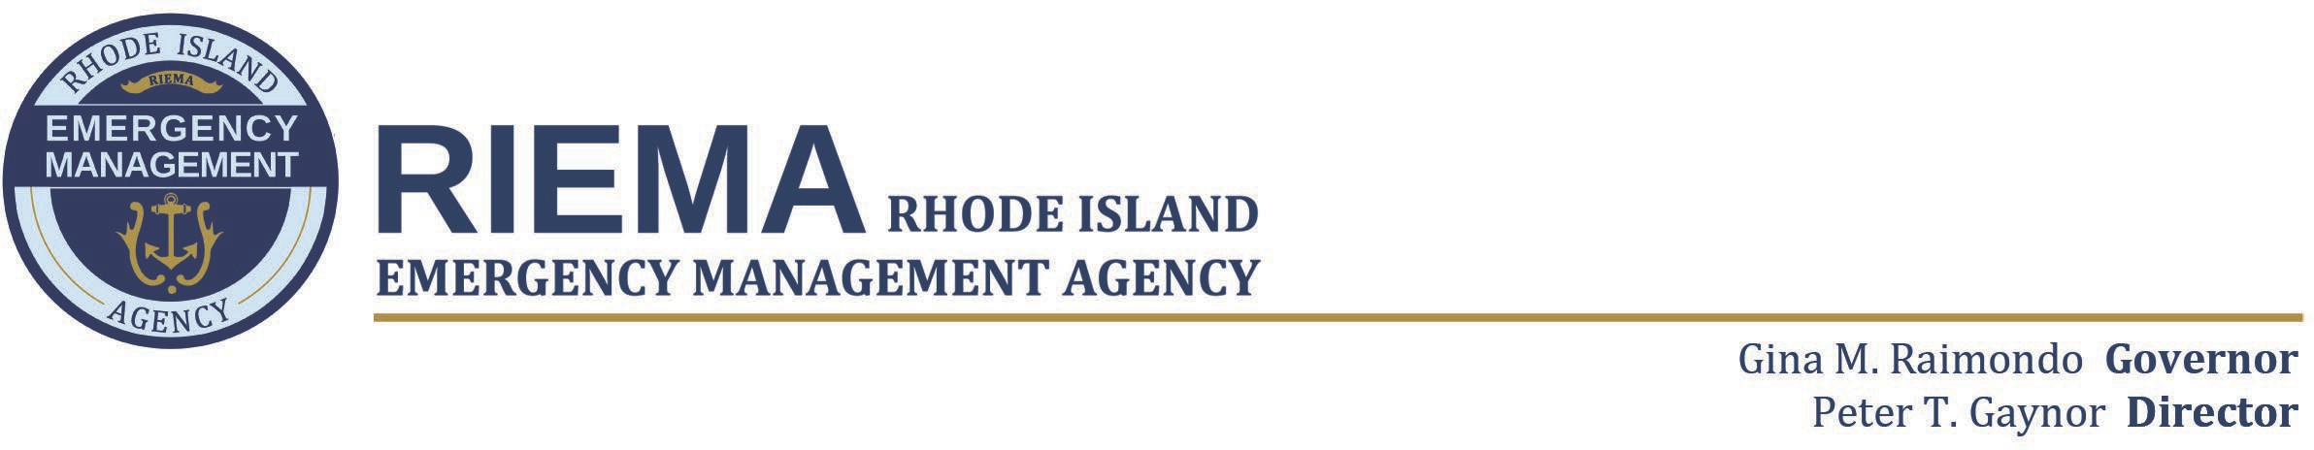
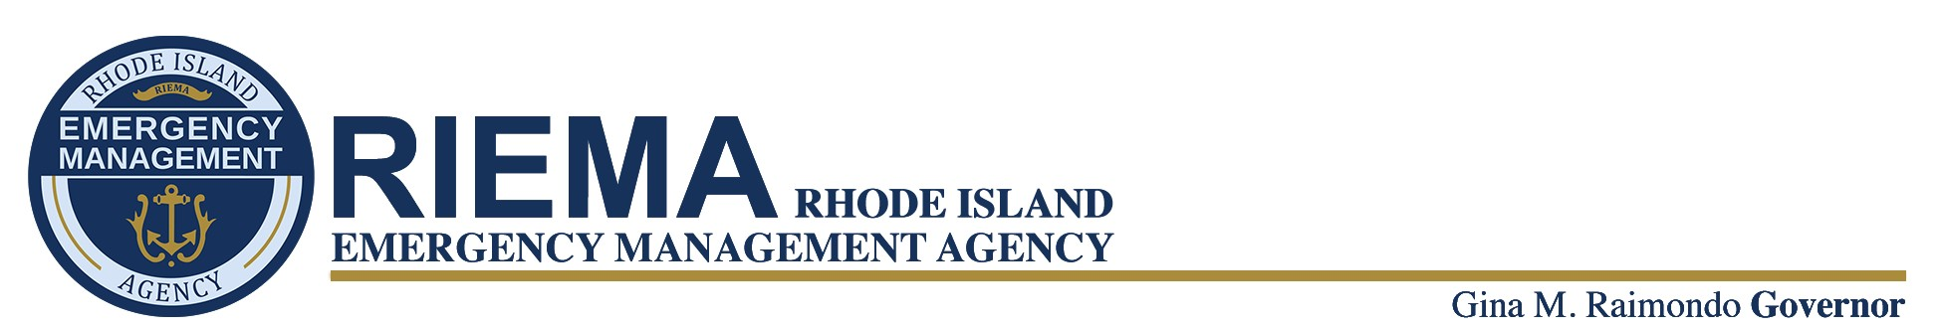
Daniel J. McKee, Governor
Marc R. Pappas, Director

Building Resilient Infrastructure and Communities (BRIC) Notice of Funding Opportunity (NOFO)

Purpose:
Fiscal Year 2023 Building Resilient Infrastructure and Communities (BRIC) Program
BRIC is a FEMA pre-disaster hazard mitigation program that replaces the Pre-Disaster Mitigation (PDM) program.
The priorities for the BRIC program are to:
- Incentivize natural hazard risk reduction activities that mitigate risk to public infrastructure
- Incorporate nature-based solutions, including those designed to reduce carbon emissions
- Enhance climate resilience and adaptation
- Promote equity and prioritize disadvantaged communities as referenced in Executive Order 14008
- Increase funding to applicants that facilitate the adoption and enforcement of the latest published editions of building codes
The Fiscal Year 2023 (FY 23) BRIC NOFO can be accessed at Fiscal Year 2023 NOFO

RIEMA encourages reviewing the BRIC NOFO before applying, as it provides detailed program information and other grant application and administration requirements.

Cost Share:
A cost share is required for all sub-applications funded under this program. The non-federal cost share may consist of cash, donated or in-kind services, materials, or any combination thereof. FEMA will provide 100 percent federal funding for management costs. The cost share for BRIC is as follows:
- Generally, the cost share for this program is 75% federal and 25% non-federal (local).

Initial Eligibility Information
To be eligible for BRIC funding, FEMA requires all sub applicants to have a current FEMA- approved Hazard Mitigation Plan by the application deadline AND at the time of obligated funding. All activities submitted for consideration must be consistent with the State standard or enhanced hazard mitigation plan and the applicant's hazard mitigation plan for the local jurisdiction in which the activity is located.

Eligible Applicant/Sub-applicants:
- State Agencies
- Local Governments
- Tribal Governments/Communities - Indian tribes or authorized non-profit tribal organizations
- Private Non-profit Organizations - Certain private non-profit organizations or institutions providing like-government services and facilities.
- Individuals or businesses may not apply directly to the State or FEMA; however, eligible local governments or private non-profit organizations may apply on their behalf.

Available Funding:
For FY 23, FEMA will distribute up to $1 billion through the BRIC grant program in the following manner:
- State/Territory Allocation: $112 million (up to $2 million per applicant.)
- National Competition for Mitigation Projects: $701,000,000 (estimated). Any funds that are not awarded from the State/Territory Allocation will be re-allocated.
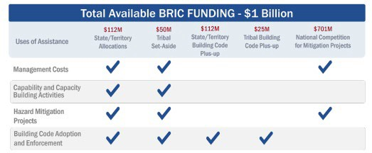

The funding caps (federal share) for the BRIC program are as follows:
- Set aside for Rhode Island as an Applicant is: $2,000,000
  - Up to $1,500,000 may be used for Capability and Capacity Building activities per applicant.
- Tribal Set-Aside Activity Caps: The combined cost of the applicant’s capability- and- capacity building activities under the Tribal Set-Aside must not exceed $1,000,000 per applicant.
- Mitigation Projects that exceed the $1,000,000 will be submitted through the National Competition Cap for funding: Sub-applicants are limited to $50 million per sub application.

Eligible Activities:
FEMA will fund the following uses of assistance through BRIC:
- Capability- and Capacity-Building Activities can be submitted under the State/Territory Allocation and Tribal Set-Aside. These are activities that enhance the knowledge, skills, and expertise of the current workforce to expand or improve the administration of mitigation assistance.
- Mitigation Projects can be submitted under the State/Territory Allocation, Tribal Set- Aside, and the national competition. Mitigation projects are cost-effective projects designed to increase resilience and public safety; reduce injuries and loss of life; and reduce damage and destruction to property, critical services, facilities, and infrastructure.
- Management Costs can be submitted under the State/Territory Allocation, Tribal Set- Aside, and national competition. Management costs allow FEMA to provide financial assistance to reimburse the recipient and subrecipient for eligible and reasonable indirect costs, direct administrative costs, and other administrative expenses associated with a specific mitigation project or C&CB activity.

Application Process:
- Sub-recipients will submit a Notice of Intent (NOI) via email to RIEMA Planning and Mitigation at raeanne.culp@ema.ri.gov .

- Upon approval of NOI, Eligible sub-applicants will be required to submit project applications through FEMA Grants Outcome (FEMA GO), which is the award management system for BRIC. https://go.fema.gov/ . Application period for FY 23 BRIC opened on 10/16/2023.

  - Registering and applying for an award under FEMA GO portal is a multi-step process and requires time to complete. Sub-applicants should read the registration instructions carefully and prepare the information requested before beginning the registration process provided in the Notice of Funding Opportunity (NOFO) FY 2023 Building Resilient Infrastructure and Communities. FY 2023 BRIC NOFO
  - NOTE: Reviewing and assembling the required information before beginning the registration process will alleviate last-minute searches for required information.
  - The registration process can take up to 4 weeks to complete. To ensure a project application meets the deadline, sub-applicants are advised to start the required steps well in advance of their submission.

- Sub-applications will be reviewed and required to meet Project Eligibility, Application Completeness, Benefit Cost Analysis (BCA), Engineering Feasibility, Mitigation Plan Status, and Environmental and Historic Preservation Review eligibility. Sub-applications are to be completed in FEMA GO by 2/1/2024, to allow time for any requests for

information to be completed. Sub-applications that are incomplete in FEMA GO by 2/05/2024 will be considered late and will not be submitted for funding consideration.

Other Key Dates in FEMA GO Application Process
Event |  | Suggested Deadline for Completion
Obtain DUNS Number |  | Four weeks before application period opens
Obtain a valid EIN |  | Four weeks before application period opens
Create an account with login.gov |  | Four weeks before application period opens
Register in SAM or updating SAM registration |  | Four weeks before application period opens
Register with FEMA GO |  | One week before application period opens
Submit the final application in FEMA GO |  | RIEMA Deadline - 2/1/2024

Links:
Rhode Island Emergency Management Agency (RIEMA) – Hazard Mitigation Section http://www.riema.ri.gov//planning/hazardmitigation/index.php

Rhode Island Emergency Management Agency (RIEMA) – Hazard Mitigation Section http://www.riema.ri.gov//grants/index.php

FEMA Building Resilient Infrastructure and Communities https://www.fema.gov/grants/mitigation/building-resilient-infrastructure-communities

FEMA Grants Outcome (FEMA GO) https://go.fema.gov/ . The step-by-step instructional desktop guides can be found by visiting User Manual (fema.gov)

Contact Information:
Rae-Anne Culp
State Hazard Mitigation Officer 401-536-5248
raeanne.culp@ema.ri.gov

